**1.Write an algorithm to find the largest among three different numbers entered by user.**

Ans:

Step 1: Start

Step 2: Declare variables a,b and c.

Step 3 : Input variables a,b and c.

Step 4: If a>b

If a>c

Display a is the largest number.

Else

Display c is the largest number.

Else

If b>c

Display b is the largest number.

Else

Display c is the greatest number.

Step 5: Stop

2. Write an algorithm to determine the sum of individual digits of a given integer.

Ans:

Step 1: Start

Step 2: Declare variables N, Sum.

Step 3:  Input N

Step 4:  Sum = 0

Step 5:  While (N != 0)

                        Sum = Sum + N % 10;;

                        N = N / 10;

Step 6:  Print Sum

Step 7: Stop

3. Write an algorithm to print the reverse of a number read as input.

Step 1: START

Step 2: Input N

Step 3: rev=0

Step 4: while(N!=0)

rev = rev * 10 + N % 10

N = N / 10

Step 5: End while

Step 6: Stop

4.Write an algorithm to check whether a number entered by user is prime or not.

Step 1: Start

Step 2: Declare variables n,i,flag.

Step 3: Initialize variables

flag←1

i←2

Step 4: Read n from user.

Step 5: for i=2 until i<=(n/2), i++

5.1 If remainder of n%i equals 0 then

flag←0

break and go to step 6

Step 6: If flag=0

Display n is not prime

else

Display n is prime

Step 7: End for

Step 7: Stop

5. Write an algorithm to generate the first 100 prime numbers

Step 1: START

Step 2: Set N = 2 and c = 0

Step 3: while ( c<=100)

Step 4: Set flag = 0

Step 5: for i=2 to N/2 in steps of 1 do

Step 6: if N % i = 0 then

Step 7: Update flag = 1 and break for loop

Step 8: If flag = 0 then

Step 9: Print N and update c = c+1

Step 10: Update N = N+1

Step 11: Loop ends

Step 12: Stop.

6. Write an algorithm to input 10 numbers, sort them in ascending order and to display them.

Step 1: START

Step 2: Declare int array A of size 10

Step 3: for i = 0 to 9 in steps of 1 do

Step 4: Input A [ i ]

Step 5: End of i for loop

Step 6: for i = 0 to 9 in steps of 1 do

Step 7: for j = 0 to 9-i in steps of 1 do

Step 8: If A [ j ] > A [ j+1 ] then

T = A [ j ]

A [ j ] = A [ j+1 ]

A [ j+1 ] = T

Step 9: End of j for loop

Step 10: End of i for loop

Step 11: for i = 0 to 9 in steps of 1 do

Step 12: Print A [ i ]

Step 13: End of i for loop

Step 14: STOP

7. Write an al.gorithm to find all roots of a quadratic equation ax2+bx+c=0.

Step 1: Start

Step 2: Declare variables a, b, c, D, r1, r2, rp and ip;

Step 2.1: if a, b ,c all are 0 then display input correct values.

Step 3: Calculate discriminant

D←b*b-4ac

Step 4: If D≥0

r1←(-b+√D)/2a

r2←(-b-√D)/2a

Display r1 and r2 as roots.

Else

Calculate real part and imaginary part

rp←b/2a

ip←√(-D)/2a

Display rp+j(ip) and rp-j(ip) as roots

Step 5: Stop

**CONDITIONAL STATEMENTS**

1. A cashier has currency notes of denominations 10, 50 and 100. Write a C program which accepts

an amount to be withdrawn, and prints the total number of currency notes of each denomination the

cashier will have to give to the withdrawer.

include <stdio.h>

int main()

{

int t,f,h,m;

printf("Enter the amout to be withdrawn=");

scanf("%d",&m);

h=m/100;//calculates the no of notes of Rs100

f=(m%100)/50;//Calculates the notes of Rs50

t=((m%100)%50)/10;//Calculates the notes of Rs10

printf("Enter the no of notes of Rs 100=%d\n",h);

printf("Enter the no of notes of Rs 50=%d\n",f);

printf("Enter the no of notes of Rs 10=%d\n",t);

return 0;

}

OUTPUT:

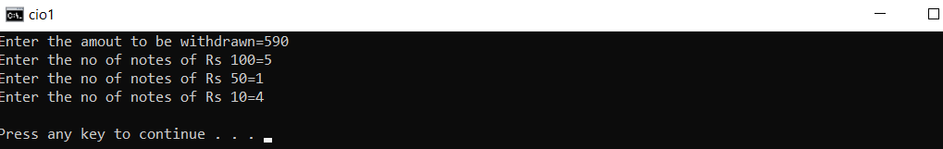

**2.The length and breadth of a rectangle are input through the keyboard. Write a programme to determine (i) radius of a circle and ratio of perimeters of the rectangle and the circle if the areas of the rectangle and the circle are equal (ii) radius of the circle and the ratio of the areas of the rectangle and the circle if the perimeters of the rectangle and the circle are equa**l.

#include <stdio.h>

#include <math.h>

int main()

{ float l,b,r1,r2,prr,arr,area;

int ch;

printf("1-->Area of the circle and the rectangle are equal\n");

printf("2->Perimeter of the circle and the rectangle are equal");

printf("\nENter Your choice =");

scanf("%d",&ch);

switch(ch)

{ case 1: printf("\nEnter length and breadth of the rectangle= ");

scanf("%f %f",&l,&b);

area=l*b;

r1=pow(area/3.141,0.5);

prr=(l+b)/(3.14*r1);

printf("The radius of the circle =%f\n",r1);

printf("The ratio of perimeter of the rectangle and the circle=%f\n",prr);

break;

case 2: printf("\nEnter length and breadth of the rectangle= ");

r2=(l+b)/3.14;

arr=(l*b)/(3.14*r2*r2);

printf("The radius of the circle =%f\n",r2);

printf("The ratio of the area of the rectangle and the circle =%f",arr); break;

default:printf("Wrong choice");

}

return 0;

}

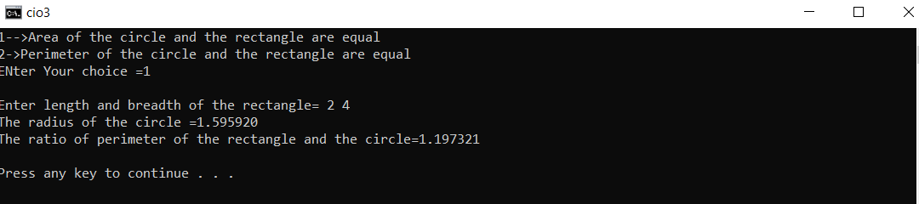

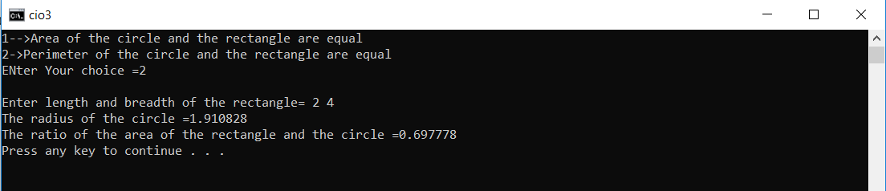

**3. If a five-digit integer is input through the keyboard, write a program to print a new number by adding one to each of its digits. For example if the number that is input is 12391 then the output should be displayed as 23402.**

#include <stdio.h>

#include <math.h>

int main()

{

int i,n,d,r,c=0;

printf("Enter a no = ");

scanf("%d",&n);

for(i=n;i>=1;i=i/10)

c++;

int p=c;

for(i=1;i<=p;i++)

{

c--;

r=n/pow(10,c);

d=(r%10)+1.0;

if(d==10)

d=0;

printf("%d",d);

}

return 0;

}

**OUTPUT:**



**4. Read a five-letter word into the computer, then encode the word on a letter-by-letter basis by subtracting 30 from the numerical value that is used to represent each letter. Thus if the ASCII character set is being used, the letter a (which is represented by the value 97)would become a C(represented by the value 67),etc. Write out the encoded version of the word**

#include <stdio.h>

int main()

{

char ch[5];

int i;

printf("Enter character= ");

scanf("%s",ch);

for(i=0;i<5;i++)

ch[i]=ch[i]-30;

for(i=0;i<5;i++)

printf("%c",ch[i]);

return 0;

}

**OUTPUT**

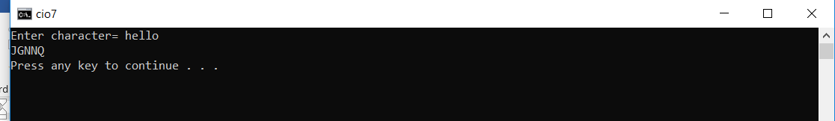

**5. Write a program to check whether a triangle is valid or not, when (i) the three angles of the**

**triangle are entered through the Keyboard (ii) three sides of the triangle are entered through the**

**keyboard.**

#include <stdio.h>

int main()

{

int ch, side1, side2, side3,angle1,angle2,angle3;

printf("Press 1-> to Enter 3 angles of a triangle\n");

printf("Press 2-> to Enter 3 sides of a triangle\nEnter your choice=");

scanf("%d",&ch);

switch(ch)

{

case 1: printf("\nEnter the three angles in degrees= ");

scanf("%d %d %d",&angle1,&angle2,&angle3);

if((angle1+angle2+angle3)==180)

printf("Triangle is valid.");

else

printf("Triangle is not valid.");

break;

case 2: printf("ENter the three sides=");

scanf("%d %d %d",&side1,&side2,&side3);

if((side1 + side2 > side3) && (side1 + side3 > side2) && (side2 + side3 > side1))

{

printf("Triangle is valid.");

}

else

{

printf("Triangle is not valid.");

}

break;

default:printf("Wrong Choice entered");

}

return 0;

}

**OUTPUT:**

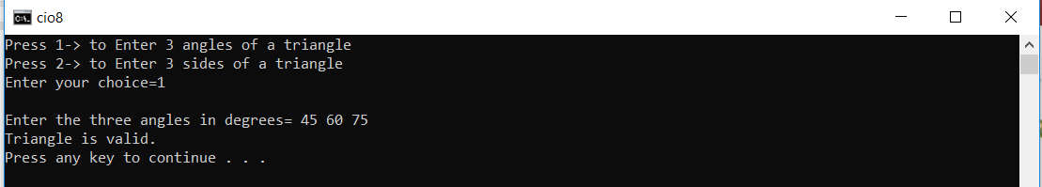

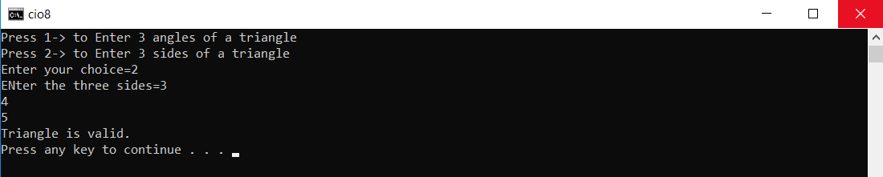

**6. Given three points (x1, y1), (x2, y2) and (x3, y3), write a program to check if all the three points fall on one straight line.**

#include <stdio.h>

int main()

{

float x1,y1,x2,y2,x3,y3,d;

printf("Enter x1 & y1=");

scanf("%f %f",&x1,&y1);

printf("Enter x2 & y2=");

scanf("%f %f",&x2,&y2);

printf("Enter x3 & y3=");

scanf("%f %f",&x3,&y3);

//We are finding the area of the triangle formed by these points

d=(x1*1.0*(y2-y3))-(x2*1.0*(y1-y3))+(x3*1.0*(y1-y2));

if(d==0)

printf("The points are collinear");

else

printf("The points are not collinear");

return 0;

}

**OUTPUT:**

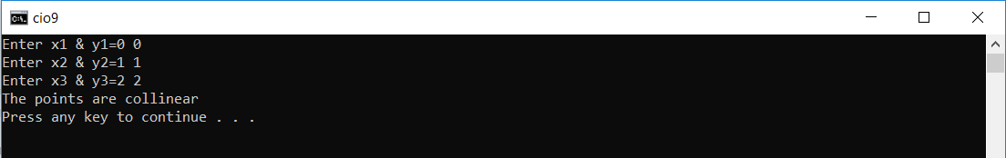

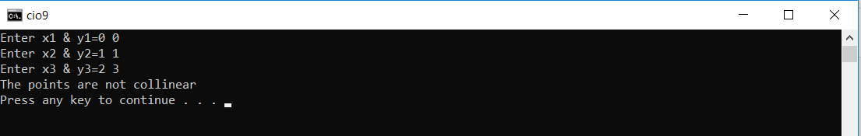

**7. Given the coordinates (x, y) of a center of a circle and its radius, write a program which will determine whether a point lies inside the circle, on the circle or outside the circle. (Hint:#include <math.h>. Use sqrt( ) and pow( ) functions)**

#include <stdio.h>

#include <math.h>

int main()

{

float xc, yc, xp, yp, r;

printf("ENTER THE X - COORDINATE OF CENTER : ");

scanf("%f", &xc);

printf("ENTER THE Y - COORDINATE OF CENTER : ");

scanf("%f", &yc);

printf("ENTER THR RADIUS OF THE CIRCLE : ");

scanf("%f", &r);

printf("ENTER THE X - COORDINATE OF POINT : ");

scanf("%f", &xp);

printf("ENTER THE Y - COORDINATE OF POINT : ");

scanf("%f", &yp);

float pos =pow(xp - xc,2) + pow(yp - yc,2) - pow(r,2);

if (pos > 0)

printf("RESULT : OUTSIDE THE CIRCLE");

if (pos < 0)

printf("RESULT : INSIDE THE CIRCLE");

if (pos == 0)

printf("RESULT : ON THE CIRCLE");

return 0;

}

**OUTPUT:**

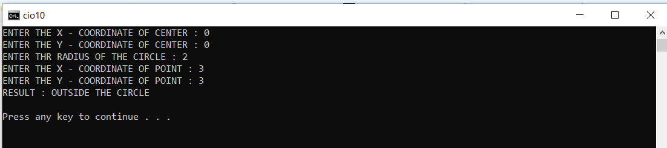

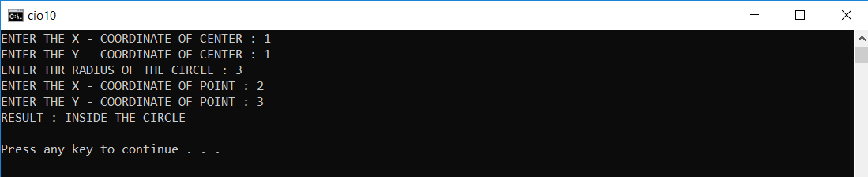

**8. Any character is entered through the keyboard, write a program to determine whether the character entered is a capital letter, a small case letter, a digit or a special symbol.**

#include <stdio.h>

int main()

{

char ch;

printf("Enter character=");

scanf("%c",&ch);

int a=ch;

if(a>=65&& a<=90)

printf("It is a capital letter\n");

else if(a>=97&&a<=122)

printf("It is a small letter\n");

else if(a>=48&&a<=57)

printf("It is a digit\n");

else

printf("It is a special character\n");

return 0;

}

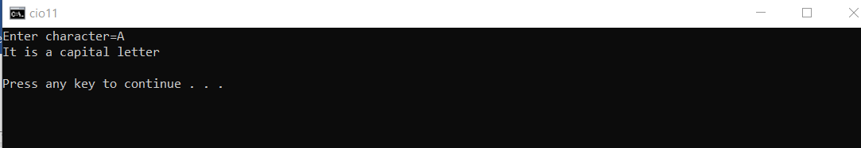**OUTPUT:**

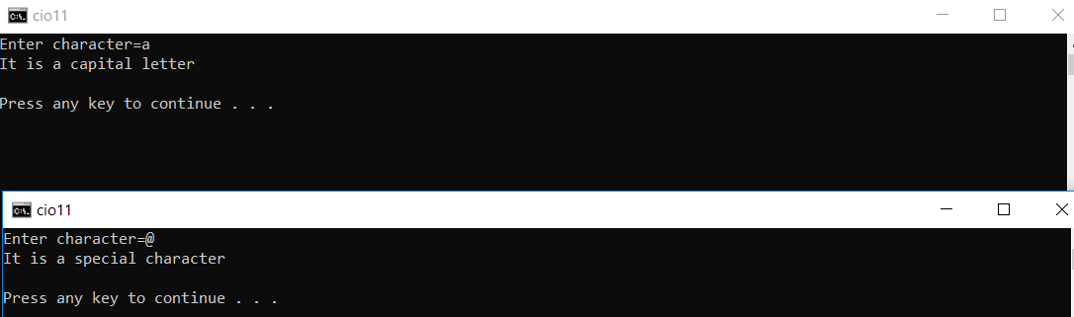

**9. Given as input an integer number of seconds, write a program to print as output the equivalent time in hours, minutes and seconds. Recommended output format is something like 7322 seconds is equivalent to 2 hours 2 minutes 2 seconds.**

#include <stdio.h>

int main()

{

int s,h,m,s1;

printf("Enter the time in seconds=");

scanf("%d",&s);

h=s/3600;//Calculate hours

m=(s%3600)/60;//calculate minutes

s1=((s%3600)%60);//calculate seconds

printf("%d seconds = %d hours %d minutes %d seconds",s,h,m,s1);

return 0;

}

**OUTPUT:**

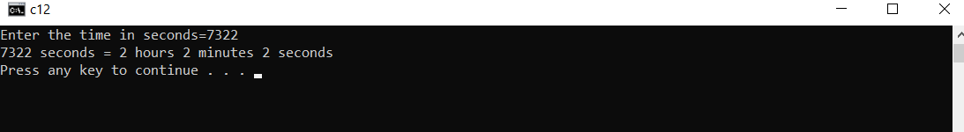

**10. Write a program which accepts two number X, Y and creates a third number Z by appending Y after X. Example: if X=12 and Y=345 then Z=12345.**

#include <stdio.h>

#include <math.h>

int main()

{

int X,Y,i,c=0,Z;

printf("Enter X and Y=");

scanf("%d %d",&X,&Y);

//To calculate the no of digits in y

for(i=Y;i>=1;i=i/10)

c++;

Z=X*pow(10,c)+Y;

printf("The appended no =%d",Z);

return 0;

}

**OUTPUT:**

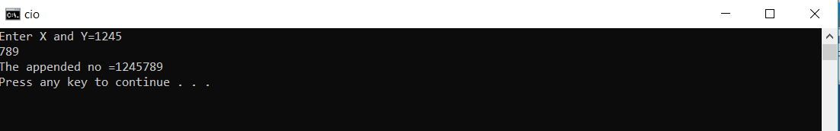

**LOOPS**

**1. Write a C program to find out sum of the following series.**

**S = 1@ + 2@ + 3@ + 4@ + … + n@**

**where, n@ is the sum of all factors of n. Example: 6@ = 1+2+3+6 = 12**

#include <stdio.h>

int main()

{

int n,s=0,i,j;

printf("Enter a no = ");

scanf("%d",&n);

for(i=1;i<=n;i++)

{

//TO FIND SUM OF THE FACTORS

for(j=1;j<=i;j++)

if(i%j==0)

s+=j;

printf(" %d@ ",i);

if(i<n)

printf("+");

}

printf(" = %d",s);

return 0;

}

**OUTPUT:**

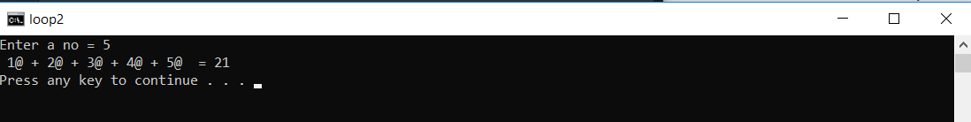

**2. Write a program to print the multiplication table of the number entered by the user. The table**

**should get displayed in the following form.**

**29 * 1 = 29**

**29 * 2 = 58**

**... ... ...**

#include <stdio.h>

int main()

{

int a,i,b;

printf("a * b = c\n\n Enter a =");

scanf("%d",&a);

printf("Enter b = ");

scanf("%d",&b);

for(i=1;i<=b;i++)

printf("%d * %d = %d\n",a,i,(a*i));

return 0;

}

**OUTPUT:**

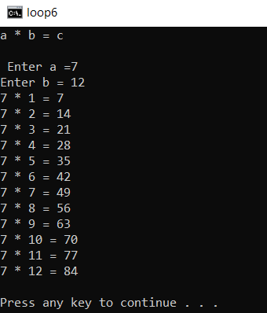

**3. Write a C program to print the first n numbers of the Fibonacci sequence. The Fibonacci sequence is constructed by adding the last two numbers of the sequence so far to get the next number in the sequence. The first and second numbers of the sequence are defined as 0 and 1.**

**We get:**

**0, 1, 1, 2, 3, 5, 8, 13, 21…**

#include <stdio.h>

int main()

{

int a,b,c,i,n;

printf("Enter a no = ");

scanf("%d",&n);

a=-1; b=1;

for(i=1;i<=n;i++)

{ c=a+b;

printf("%d ",c);

a=b;

b=c;

}

return 0;

}

OUTPUT:

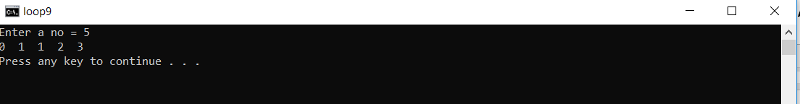

**4. Write a program which reads a positive integer value, and compute the following sequence: if**

**the number is even, halve it; if it’s odd, multiply by 3 and add 1. Repeat this process until the**

**value is 1, printing out each intermediate value. Finally the program should print how many of**

**these operations were performed. Typical output might be:**

**Inital value is 3**

**Next value is 10**

**Next value is 5**

**Next value is 16**

**Next value is 8**

**Next value is 4**

**Next value is 2**

**Next value is 1**

**Number of operations is 7**

#include <stdio.h>

int main()

{

int c=0,n;

printf("Enter a No= ");

scanf("%d",&n);

for(;n!=1;c++)

{

if(n%2==0)

n=n/2;

else

n=n*3+1;

if(c>=0)

printf("Next Value is %d\n",n);

}

printf("The No of operations =%d",c);

return 0;

}

**OUTPUT:**

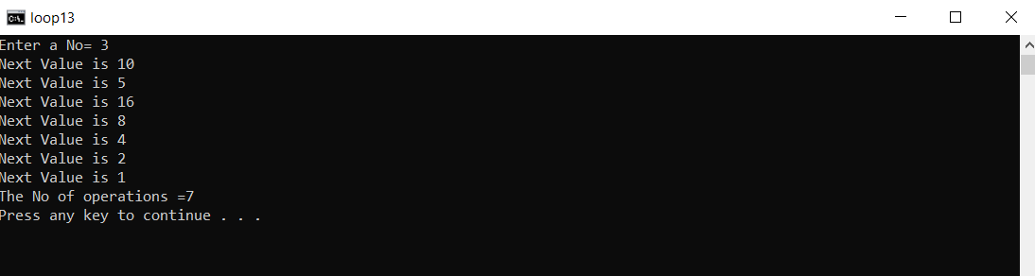

**5. Write a program to add first seven terms of the following series using a for loop:**

**1/1!+2/2!+3/3!+⋯…**

#include <stdio.h>

int main()

{

int i,j; float s=0,p;

for(i=1;i<=7;i++)

{ p=1;

for(j=1;j<=i;j++)

p=p*j;

s=s+((float)i/p*1.0);

printf(" %d/%d! ",i,i);

if(i<7)

printf("+");

}

printf("= %f",s);

return 0;

}

**OUTPUT:**

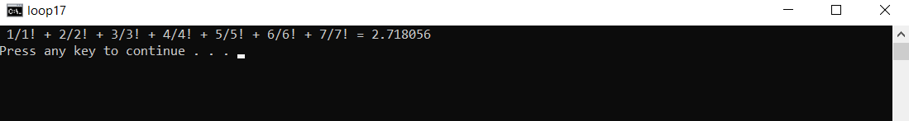

ARRAYS

**1. Write a C program to replace a square matrix by its transpose without using a second matrix.**

|  |
| --- |
| #include<stdio.h>    void main()  {      int mat[12][12];      int i,j,row,col,temp;      printf("Enter the number of rows and columns for 1st matrix\n");      scanf("%d%d",&row,&col);      printf("Enter the elements of the matrix\n");      for(i=0;i<row;i++)      {          for(j=0;j<col;j++)          {              scanf("%d",&mat[i][j]);          }      }        printf("The matrix\n");      for(i=0;i<row;i++)      {          for(j=0;j<col;j++)          {              printf("%d\t",mat[i][j]);          }          printf("\n");      }      //transpose logic using same matrix      for(i=0;i<row;i++)      {          for(j=0;j<i;j++)          {              temp=mat[i][j];              mat[i][j]=mat[j][i];              mat[j][i]=temp;          }      }        printf("The transpose of the matrix is\n");      for(i=0;i<row;i++)      {          for(j=0;j<col;j++)          {              printf("%d\t",mat[i][j]);          }          printf("\n");      }  } |

**Output:**

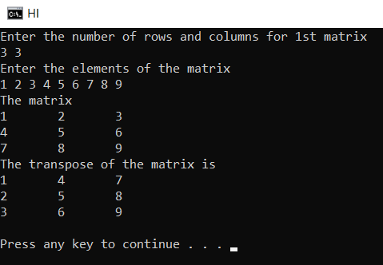

2. **Write a C program which accepts ten integers from user and prints them in ascending order. Use array to store the integers.**

#include<stdio.h>

int main()

{

int Ar[10];

int i=0,j=0,t=0;

printf("Enter 10 integers: ");

for(i=0;i<10;i++)

{

scanf("%d",&Ar[i]);

}

for(i=0;i<10;i++)

{

for(j=0;j<9-i;j++)

{

if(Ar[j]>Ar[j+1])

{

t=Ar[j];

Ar[j]=Ar[j+1];

Ar[j+1]=t;

}

}

}

printf("The integers in ascending order: ");

for(i=0;i<10;i++)

printf("%d ",Ar[i]);

return 0;

}

**OUTPUT:**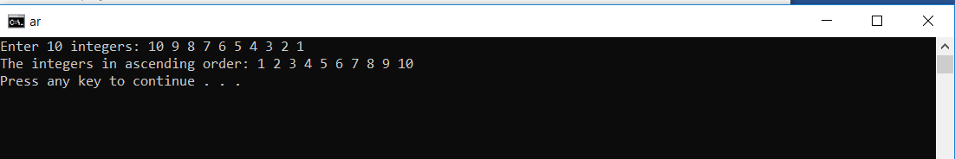

**FUNCTIONS AND POINTERS**

**1. Write a C program which accepts a string from user and counts the number of characters in the**

**string without using string library functions**

#include <stdio.h>

int main()

{

char ch[100];

int i=0;

printf("Enter a string=");

gets(ch);

for(i=0;ch[i]!='\0';i++);

printf("The no of characters=%d",i);

}

**OUTPUT:**

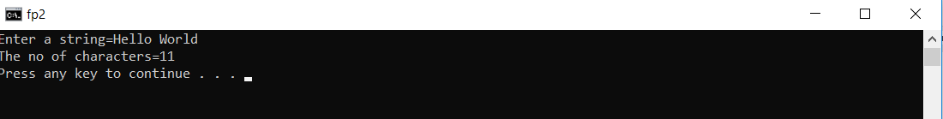

**2. Write a C program which accepts a string from user and prints the reverse of the string without**

**using string library functions.**

#include <stdio.h>

int main()

{ char ch[100]; int i=0;

printf("Enter a string=");

gets(ch);

for(i=0;ch[i]!='\0';i++);

printf("The reverse of the string is= ");

int l=i;

for(i=l-1;i>=0;i--)

printf("%c",ch[i]);

return 0;

}

**OUTPUT:**

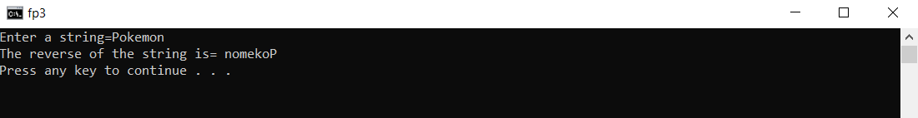

**3. Write a C program which accepts a full name from user prints the initials. Eg. SRT for Sachin**

**Ramesh Tendulkar.**

#include <stdio.h>

int main()

{

char ch[100];

int i=0;

printf("Enter a string=");

gets(ch);

for(i=0;ch[i]!='\0';i++);

int l=i;

printf("The initials = %c",ch[0]);

for(i=0;i<l;i++)

{

if(ch[i]==' ')

{

i++;

printf("%c",ch[i]);

}

}

return 0;

}

**OUTPUT:**

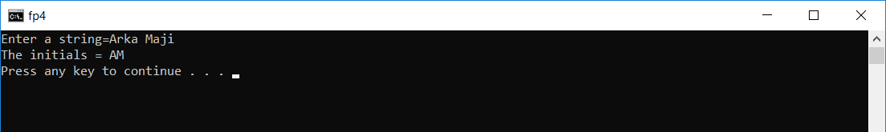

**4. Write a C program which accepts any string of the form “Ustad Bade Ghulam Ali Khan was the**

**Tansen of the 20th century” and prints it as “Ustad|Bade|Ghulam|Ali| Khan|was|the|Tansen|**

**of|the|20th|century”.**

**#include <stdio.h>**

int main()

{

char ch[100]; int i=0;

printf("Enter a string=");

gets(ch);

for(i=0;ch[i]!='\0';i++);

int l=i;

printf("The required output = ");

for(i=0;i<l;i++)

{ printf("%c",ch[i]);

if(ch[i]==' ')

printf(" | ");

}

return 0;

}

**OUTPUT:**

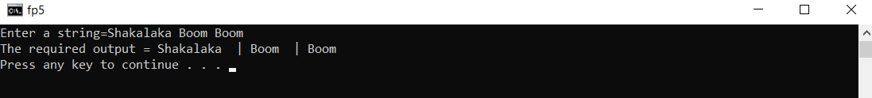

**5. Write a program that reads a line and converts it into all capitals without using any string library function. (input string may also contain capital letters)**

#include<stdio.h>

int main()

{

char line[300];

int l=0,i=0;

printf("Enter the line: ");

gets(line);

for(l=0;line[l]!='\0';l++);

for(i=0;i<l;i++)

{

if(line[i]>=97 && line[i]<=122)

{

line[i]-=32;

}

}

printf("\nThe output is: \n");

for(i=0;i<l;i++)

{

printf("%c",line[i]);

}

return 0;

}

OUTPUT:

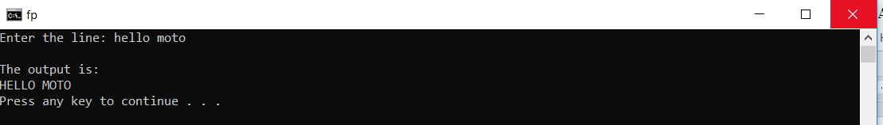

**7.Write a program to count the number of occurrences of any two vowels in succession in a line of text.**

#include <stdio.h>

int vowel (char ch);

int main()

{

int count=0;

char string[80];

printf("Enter the string :");

gets(string);

int i=0;//loop variable

while(string[i+1]!='\0')

{

if((vowel(string[i])==1)&&(vowel(string[i+1])==1))

count++;//checks if any two alphabets in succesion are vowels or not

i++;

}

printf("The occurences of successive vowels are %d\n ",count);

return 0;

}

int vowel(char ch)

{

//returns true if vowel else false

if(ch=='a'||ch=='e'||ch=='i'||ch=='o'||ch=='u'||ch=='A'||ch=='E'||ch=='I'||ch=='O'||ch=='U')

return 1;

return 0;

}

**OUTPUT:**

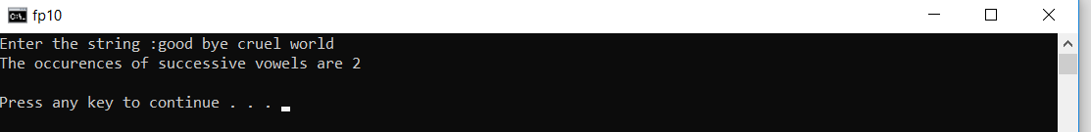

**8.Write a program that reads a line and delete from it all occurrences of the word “the”. Do not use any string library function.**

#include <stdio.h>

int main()

{

char string[80];

char newstring[80];

printf("Enter the new String : ");

gets(string);

int i=0;int j=0;//loop variables, i stores the beginning and j stores the index of the new

string

while(string[i]!='\0')

{

if(string[i]=='t'&& string[i+1]=='h' && string[i+2]=='e')//checks if the end and the

//beginning are same

{

i+=3;//increments the location of current char by 3

continue;

}

else

{

newstring[j]=string[i];

j++;

i++;

}

}

if(j!=0)

printf("The formatted string is %s\n",newstring);

else

printf("The entire string got deleted\n");

return 0;

}

**OUTPUT**

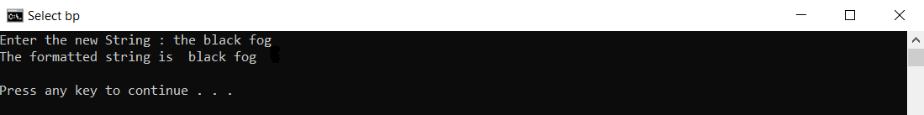

**9.Write a program that converts a string like “123” to integer 123. Do not use any string library function.**

#include<stdio.h>

int main()

{

char chars[80];

int whole=0;

printf("Enter the number to be converted : ");

gets(chars);

int i=0;//loop variable

int found=1;//makes sure the input is valid

while(chars[i]!='\0')

{

if(chars[i]>=48&&chars[i]<=57)

{

int digit= (int)chars[i]-48;//extracts the number

whole=whole*10+digit;//adds it to the original number

i++;

}

else

{

found=0;//signifies invalid input

break;

}

}

if(found)

printf("The integer is %d\n",whole);

else

printf("Bad input");

return 0;

}

**OUTPUT**

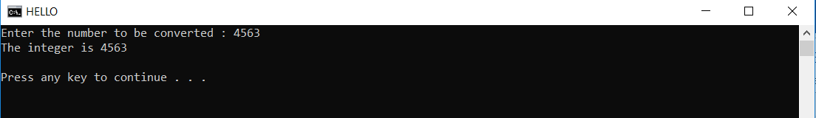

**10. Write a C program which accepts a string from user and checks whether it is palindrome or not. Do not use any string library function. [Example of a palindrome string: "abcba", “abba"]**

#include <stdio.h>

int main()

{

char string[80];

printf("Enter the string : ");

gets(string);

int found;

int i=0;

while(string[i]!='\0')

i++;

i--;

int p=i;

char ar[i];

for(i=0;i<p;i++)

{

if(string[i]==string[p-i])

found=1;

else

{found=0;break;}

}

if(found==0)

printf("Not a Palindrome\n");

else

printf("Palindrome\n");

return 0;

}

**OUTPUT:**

